%%%%%%%%%%%%%%%%%%%%%%%%%%%%%%%%%%%%%%%%%%%%%%%%%%%%%%%

**Example 5**

In this example, we explore the progression of density across the annulus. In our numerical test, we take the initial data $ρ_{0} =e^{(−30(x^{2} + y^{2})) } + 0.01$. The computational domain is $Ω = \{(x,y)| 1 ≤x^{2} + y^{2} ≤4\}$. The mesh size and time step are set as $tau =1/20000$ and $h =$ 1/16, respectively. We take



%%%%%%%%%%%%%%%%%%%%%%%%%%%%%%%%%%%%%%%%%%%%%%%%%%%%%%%

**Result**

1. **Free energy**

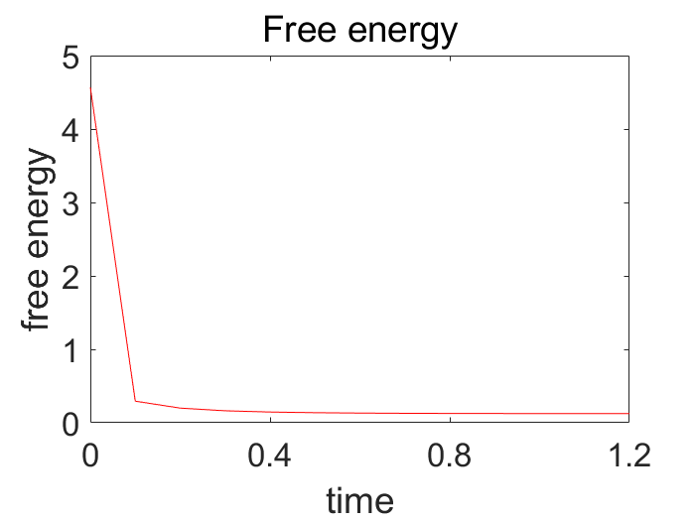

Figure 1 Mesh size(1/16), time step(tau=1/20000)

1. **The total mass**

**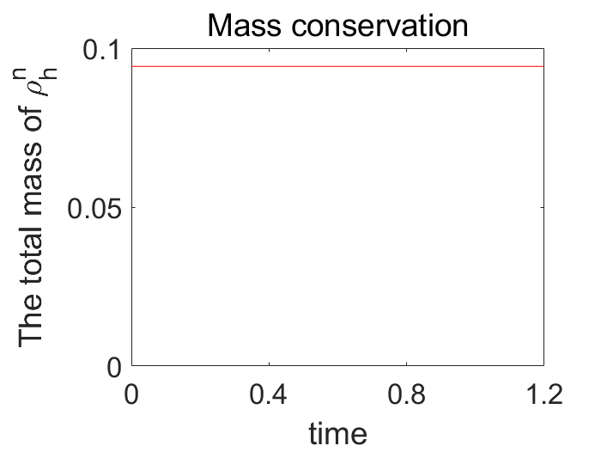**

Figure 2 Mesh size(1/16), time step(tau=1/20000)

1. **Numerical result**

|  |  |  |
| --- | --- | --- |
| rho_h_fill3_0  Figure 3 t = 0 | rho_h_fill3_4  Figure 4 t = 0.4 | rho_h_fill3_8  Figure 5 t =0.8 |
| rho_h_fill3_10  Figure 6 t = 1.0 | rho_h_fill3_11  Figure 7 t = 1.1 | rho_h_fill3_12  Figure 8 t = 1.2 |